**Progress Report-02**

- Completed first and second week on the ML course

Content:

- WEEK-1

- Supervised Single Variable Regression Problem

- Motive of the desired code is to find a “hypothesis” function (h(x)) which when given a training set, accurately predicts the corresponding value of the output variable.

H : X → Y , X is the space of input variables

Y is the space of output variables

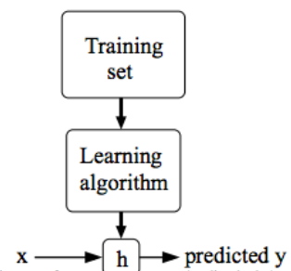

-Using the method of least squares, we define a cost function, whose main purpose is to provide an error correction value from the predicted output to the actual output.

- Our goal is to minimize this cost function, to ensure closeness to the actual result.

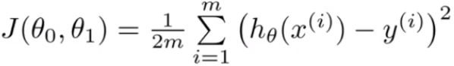

- Contour plots were used as an alternative to plot the cost function.

- Gradient descent inherently means to move in a direction of steepest slope to find the optimum parameters in order to minimize the cost function.



-The main problem of gradient descent is that cannot find the global minimum of the system if the local minimum is closer to the initial point of the iteration

- Since the cost function is usually convex and has only one global minimum, this disadvantage is compromised.

- Using batch gradient descent, we can reach the optimum solution much faster.

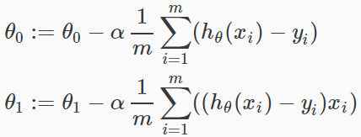

- WEEK-2

- Octave Setup and functions were discussed.

- Supervised Multivariate Regression Problem

- The hypothesis is vectorized to ensure easier implementation.

- Initial Hypothesis



- Vectorized Hypothesis

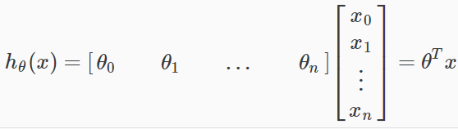

- Gradient Descent for multiple variables

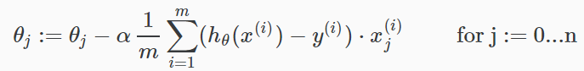

- Feature Scaling – It is used to convert the convoluted path of the contour diagram to more circular trajectory in order to achieve faster convergence. Conformation of the range of all individual features.

- Mean Normalization - subtracting the average value for an input variable from the values for that input variable resulting in a new average value for the input variable of just zero.

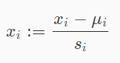

- Polynomial Regression- The optimum solution is not often achieved by simply a straight line, so we try to confine with a quadratic, cubic, quartic and so on.

- Normal Equation- It is a non-iterative way of obtaining the optimum values of the parameters required to minimize the cost function.



In case of the absence of an inverse, it may be result of the use of redundant features, or the usage of too many features, a pseudo-inverse function may be used to achieve a numerical approximation to the inverse.

- Completed Programming Assignment in Octave

